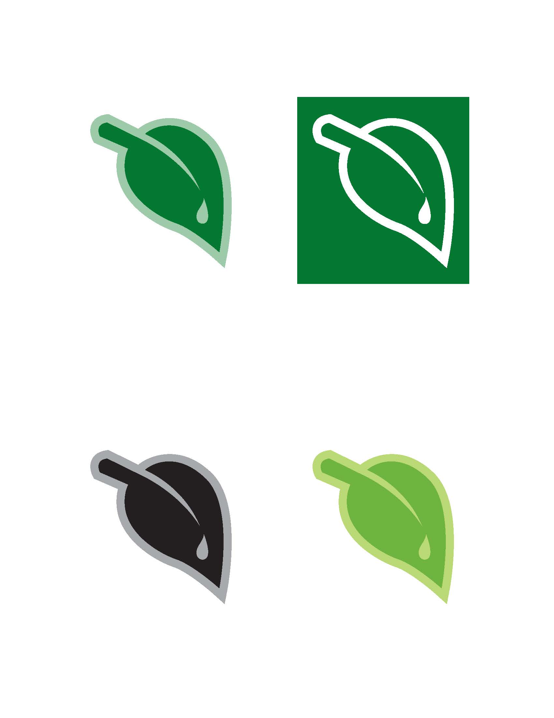 | Application for LLELA Field Use  Please fill out this application for use of the Lewisville Lake Environmental Learning Area (LLELA). Be sure to fill out all portions of the application. If you have questions, please contact Ken Steigman at 972-822-0320 or Kenneth.Steigman@unt.edu.

Course/Faculty Information
Course Title | Insert Course Title Here | Course Code | Insert the course code here.
Faculty Name | Insert Info Here | Email
Department |  | Phone
College |  | Best Way to Contact | Phone or Email?

LLELA USE Information
The Lewisville Lake Environmental Learning Area (LLELA), which sits just south of Lewisville Lake, is a living lab perfect for scientific research and environmental education purposes and provides unique opportunities for hands-on training with its vast prairieland, array of animals and diversity of waterways, including the Elm Fork of the Trinity River.

It is important to understand the various options you have for visiting LLELA each semester. The following are your available options:
- Day Laboratory: This includes one visit to LLELA at $4 per person for each visit. Faculty requesting should indicate their preferred date and an alternate rain date.

- Semester Field Study: This includes two to three visits per semester for a particular course. The flat fee for this is $200. Faculty requesting should indicate their preferred date and an alternate rain date.
Please indicate:
 | Day Laboratory |  | Semester Field Study

Number of Field Visits Per Semester
Preferred Date of Field Visit
Alternate Rain Date for Field Visit
Lab starts at: |  | Lab ends at:
Estimated Number of Students

Field Visit Expectations and Outcomes

Description of laboratory activities and objectives:
This space expands as needed to fill in your information…

Anticipated skills learned:
This space expands as needed to fill in your information…

Student assessment report of lab quality required:
This space expands as needed to fill in your information…

